FORENSICS:

1.open a zip file using script:

Opened file:

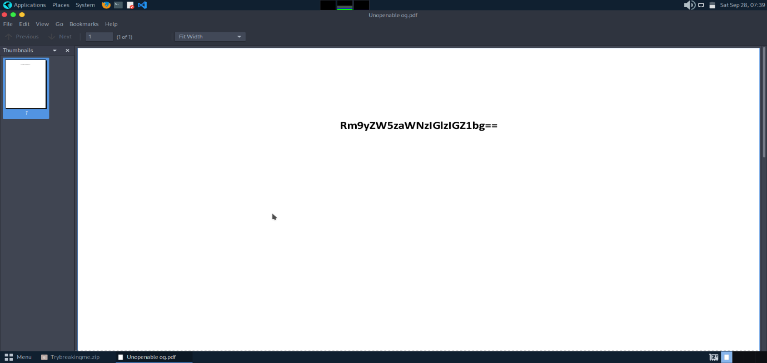

The password **"softball3"** is presumably the chosen password for a **ZIP file to be opened.**